LIBRARY MANAGEMENT SYSTEM

1.CREATING SCHEMA:

Step 1: Connect to database:

**C:\>sqlplus system/1234**

Step 2: Create table space:

**CREATE TABLESPACE e_library DATAFILE 'e_library.dat' SIZE 1M AUTOEXTEND ON;**

Step 3: Create a new user in Oracle

**CREATE USER eadmin IDENTIFIED BY admin DEFAULT TABLESPACE e_library QUOTA unlimited on e_library ;**

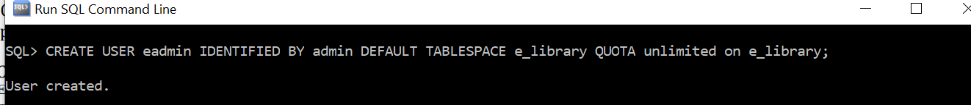

Step 4: Grant permissions

**GRANT create session TO eadmin;**

**GRANT create table TO eadmin;**

**GRANT create sequence TO eadmin;**

Step 5: Disconnect from system account and connect to eadmin

**Conn edmin/admin;**

Step 6: Create tables and sequences

I) BOOK TABLE

Create table book (code number(19) primary key,

Bookname varchar2(255),

Author varchar2(255),

Publication varchar2(255),

Subject varchar2(255),

No_of_books number(19));

Create sequence book_seq start with 100 increment by 1;

II)STUDENT INFORMATION TABLE

Create student table (libid number(19) primary key,

regno number(19),

branch varchar2(255),

section varchar2(255),

semester varchar2(255),

year_of_adm number(19));

Create sequence student_seq start with 100 increment by 1;

III) TEACHER INFORMATION TABLE

Create teacher table(tid number(19) primary key,

Name varchar2(255),

Designation varchar2(255),

Branch varchar2(255),

Contact_no number(19),

Lectures_taken number(19));

Create sequence teacher_seq start with 100 increment by 1;

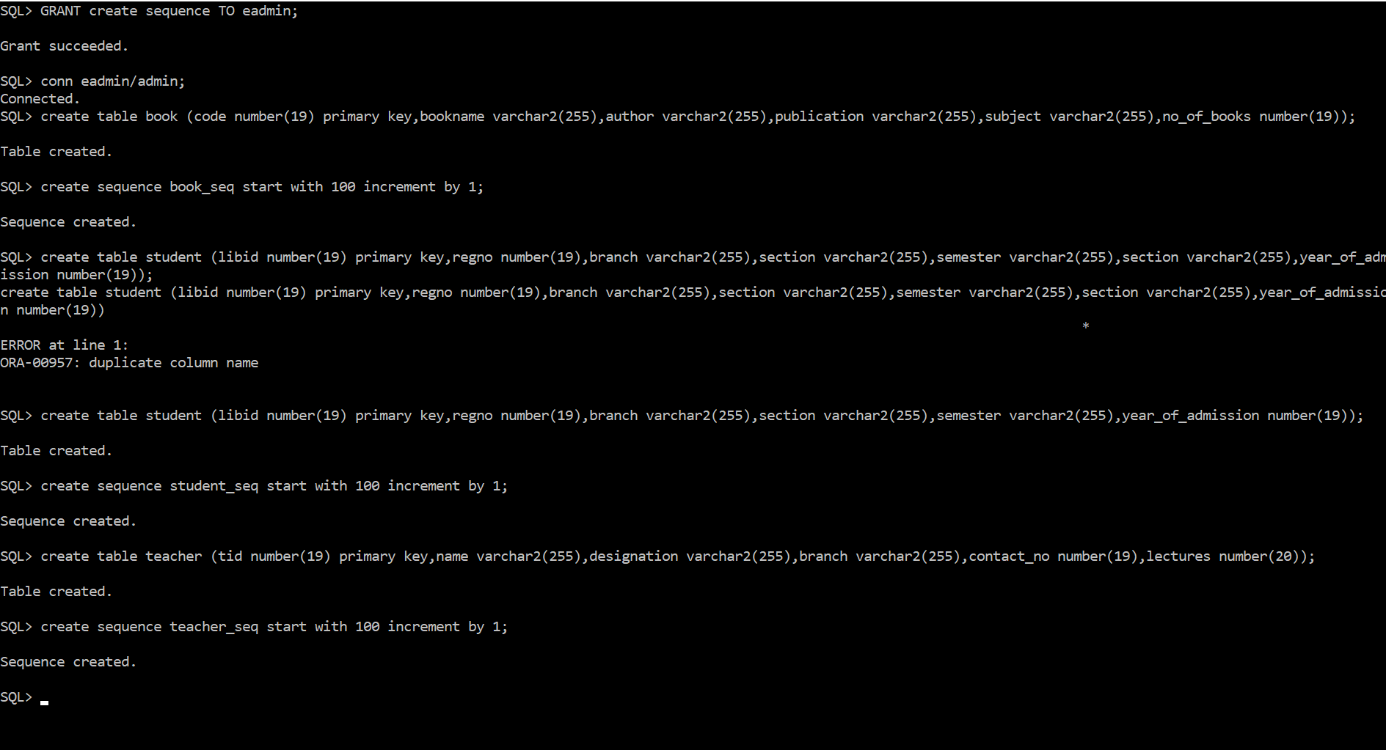

(Connecting to new user i.e eadmin, book table,student table,teacher table,sequence creation)

IV) Issue table to keep track of books issued

create table track_of_books(code number(19) references book,

libid number(19) references student,

issue_date varchar2(255),

return_date varchar2(255));

create sequence track_of_book_seq start with 100 increment by 1;

V) STUDENT LOGIN TABLE

CREATE table student_login(libid number(19) references student,

user_name varchar2(255),

password varchar2(55),

books_taken number(19));

create sequence student_login_seq start with 100 increment by 1;

VI) TEACHER LOGIN TABLE

CREATE table teacher_login(tid number(19) references teacher,

user_name varchar2(255),

password varchar2(55),

books_taken number(19));

create sequence teacher_login_seq start with 100 increment by 1;

VII) ADMIN DETAILS TABLE

create table admin_details(admin_id number(19) primary key,

name varchar2(255),

password varchar2(255));

create sequence admin_details_seq start with 100 increment by 1;

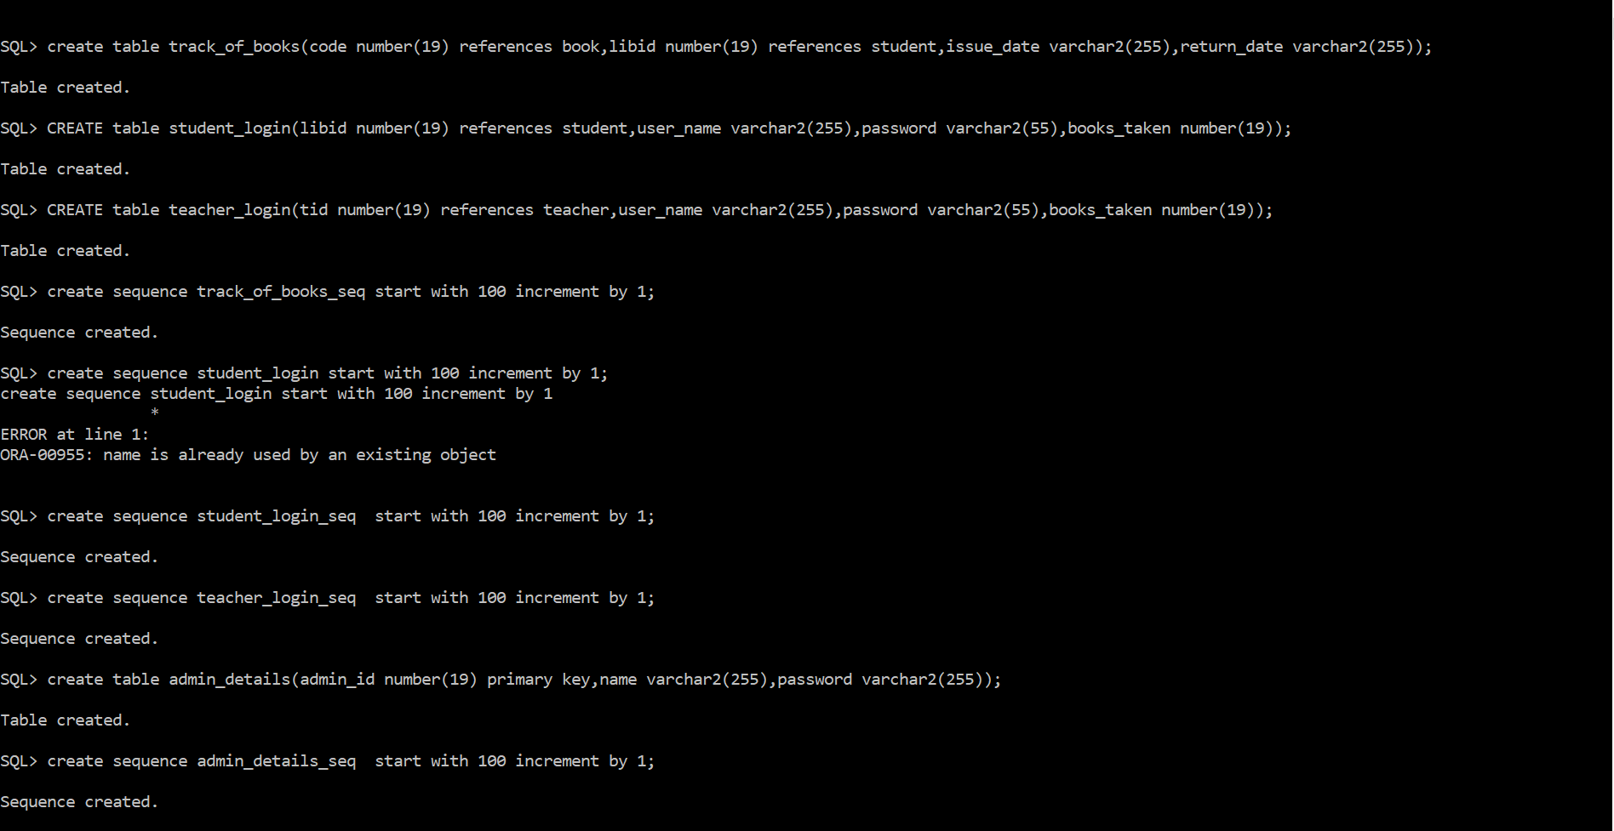

(track of books, student_login,teacher_login,admin-details tables and sequences creation)

VIII) EVENT DETAILS TABLE

create table event_table(name varchar2(255),event_date date,time varchar2(255),Mname varchar2(255),contact_number number(15),email varchar2(255),venue varchar2(255));



2. ER DIAGRAM:

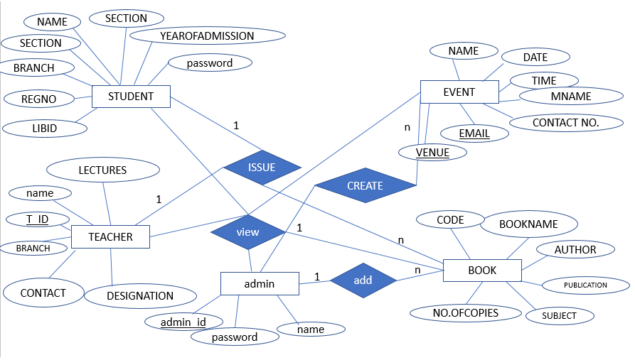

3. FORMS:

**BOOK DETAILS**

Code :

Book Name :

Author:

Publications :

Subject :

No. of copies :

SUBMIT

Student Registration

Libid:

RegNo:

Name:

Branch:

Section:

Semester:

Section:

Year of Admission:

SUBMIT

Student Login

Libid/Username:

Password:

SUBMIT

ADDING ADMIN

Name:

Password:

SUBMIT

Admin Login

id/Name:

Password:

SUBMIT

Teacher Login

Libid/Username:

Password:

SUBMIT

Teacher Registration

Name:

Branch:

Designation:

Contact Number:

Lectures:

SUBMIT

**BOOK ISSUE TABLE**

Book id :

Student id :

Issue date :

Return date :

SUBMIT

**Add EVENT**

**EVENT NAME**

**DATE**

**TIME**

**ORGANIZER NAME**

**CONTACT_NO**

**EMAIL**

**VENUE**

**SUBMIT**